Faculty of Computer Science & Engineering

Assignment Number – 5

Name : Prajyot Chandrashekhar Bhamare. F.Y. B.Tech. Division 2 (B1)

Roll no.: 102032 PRN no.: 1032190054

#include<stdio.h>  
  
void main()  
{  
 int i, n, t1 = 0, t2 = 1, nextTerm;  
 printf("Enter the number of terms: \n");  
 scanf("%d", &n);  
 printf("Fibonacci Series: ");  
 for (i = 1; i <= n; ++i) {  
 printf("%d ", t1);  
 nextTerm = t1 + t2;  
 t1 = t2;  
 t2 = nextTerm;  
 }  
}

Assignment 5 Output

Name : Prajyot Chandrashekhar Bhamare

Roll no.: 102032 PRN no.: 1032190054

Enter the number of terms:

10

Fibonacci Series: 0 1 1 2 3 5 8 13 21 34

Enter the number of terms:

15

Fibonacci Series: 0 1 1 2 3 5 8 13 21 34 55 89 144 233 377

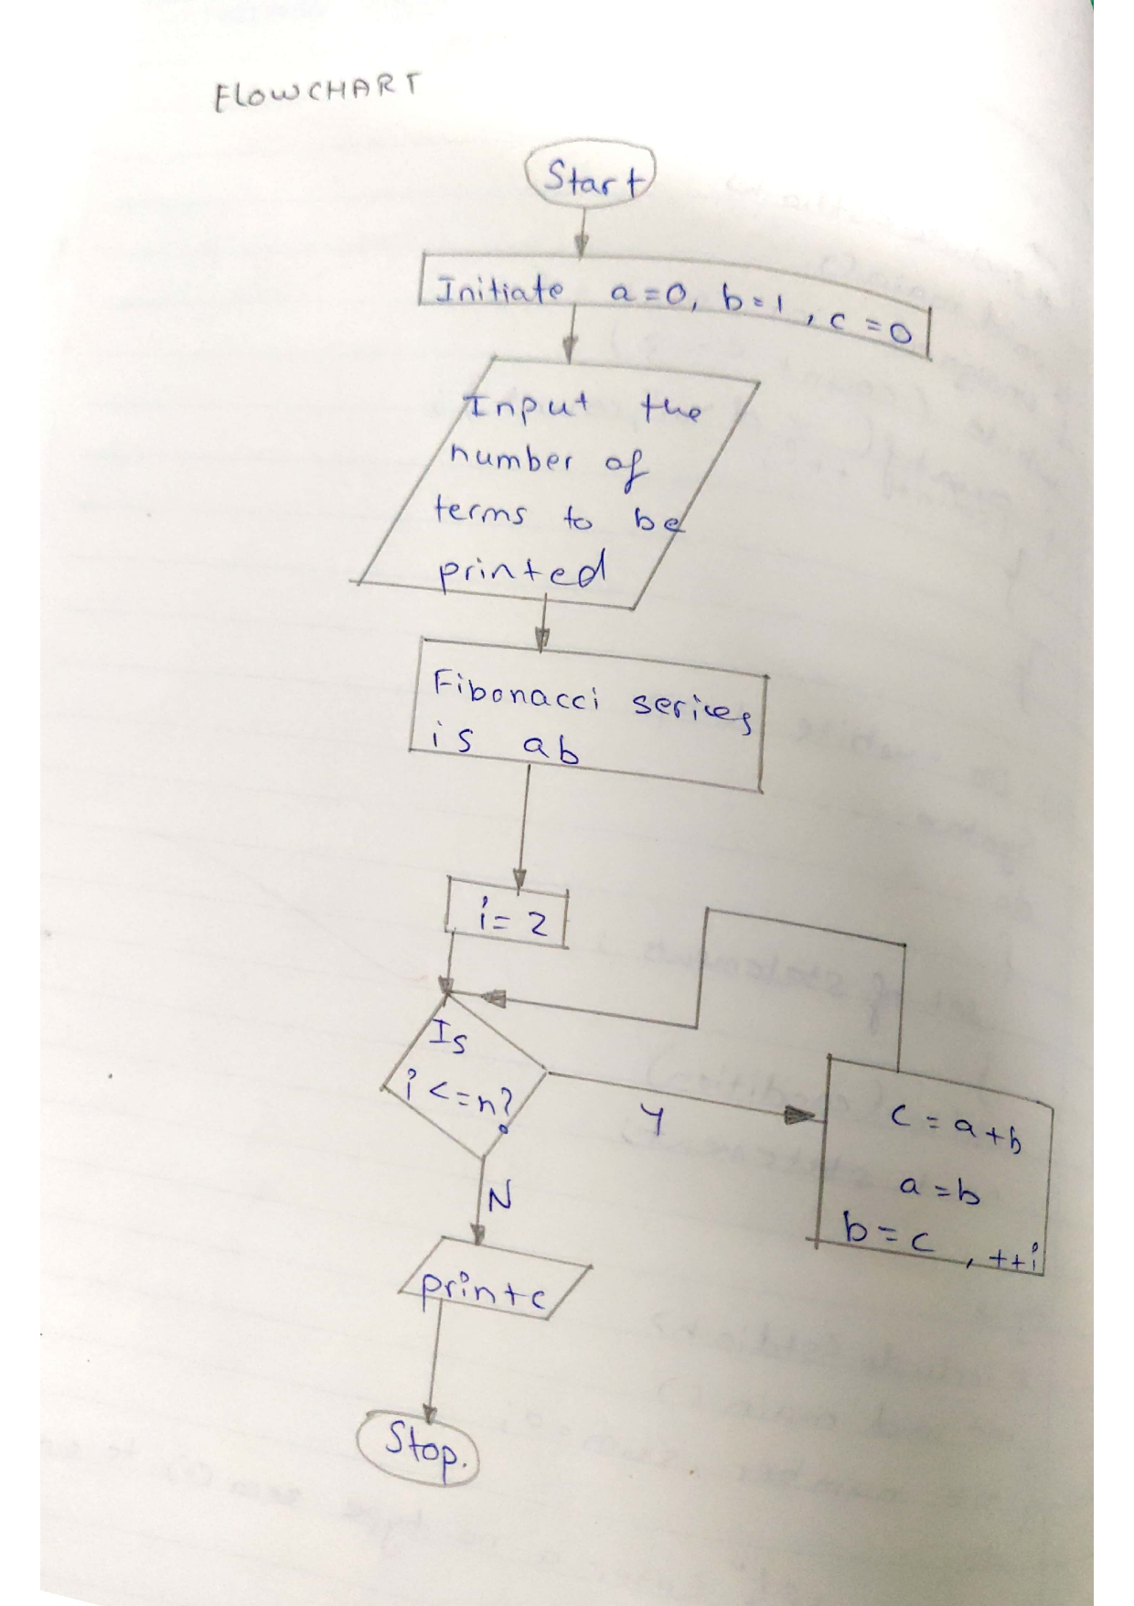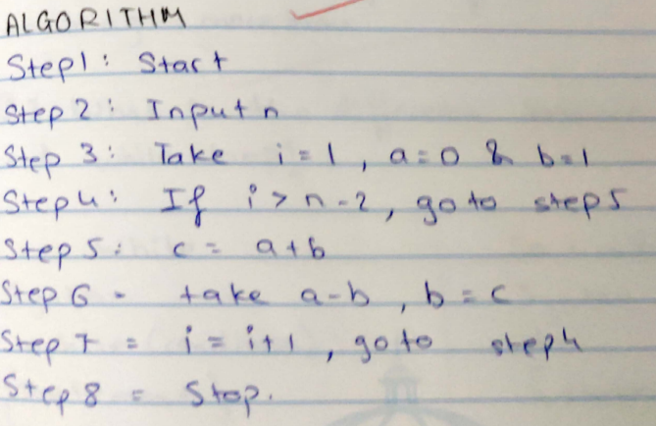

Print c

Print c